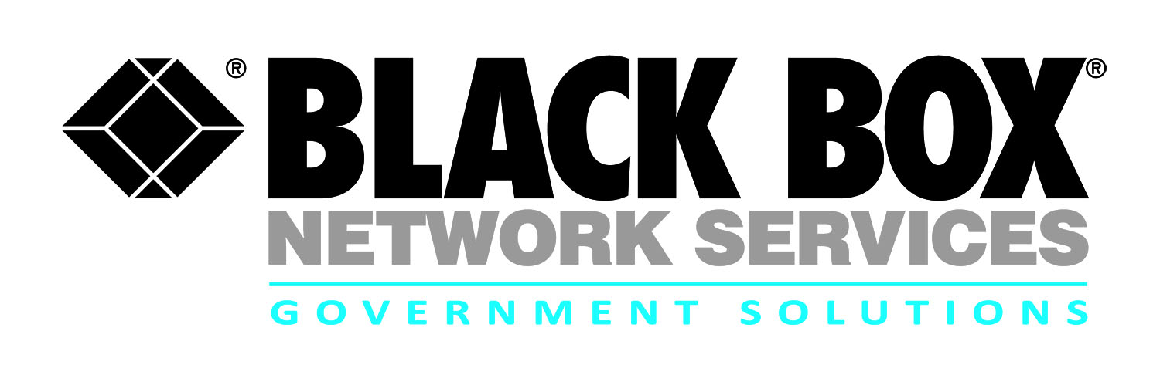
Contract review:
GSA Connections II

Contract # | GS00Q12NSD0016
POP | 2/1/15 through 1/31/21
Who is Eligible | All Federal Agencies
Agency | GSA
Gov’t Contact | 703-306-6453
Email | connectionsII@gsa.gov
CONNECTIONS II is a $5 billion, 9-year and 3 month multiple award contract that is the government’s one-stop shop for buying telecommunications, network, and communications solutions. CONNECTIONS II meets government agencies’ equipment, building, and campus infrastructure needs, and it provides professional services to support existing networks and design customized client-specific solutions.

- Operational Scope of the Global CONNECTIONS II contract is an exact fit to Black Box’s core competencies and world-wide footprint.
- Black Box is a leading provider of networking and telecommunications equipment of strategic manufacturers and also manufactures many products required for solutions, resulting in an overall reduction in cost.
- Black Box’s strategic teaming partners enhance our solutions capabilities in communications, infrastructure, technical support and maintenance.
- Black Box provides exceptional, personalized service through our small business mentality and our large business resources, allowing for fast turnaround for all task order requests.
- Black Box offers around-the-clock and around-the-globe support for all our solution implementations through five fully integrated Technical Assistance Centers located in the U.S. and more than 3,000 technical engineering and support Team Members worldwide.

Download Connections II Brochure
Download Connections II Pricing
Download Connections II Redacted Contract

Solution Sets

- Voice and data equipment, services, and solutions
- Communications and networking;
- Building or campus facility preparation;
- Operations, administration, and management (OA&M)
- Customer service and technical support.

Whether an agency requires transition planning and integration services or infrastructure installation and implementation, CONNECTIONS II provides a comprehensive solution for all federal agency telecommunications needs.

For more information:

Robert Forshay
Partner Alliance Manager
Government Solutions
Black Box Network Services
781-292-3613 or robert.forshay@blackbox.com

Joe Haynes
Account Executive
Government Solutions
Black Box Network Services
703- 885-7906or joe.haynes@blackbox.com
http://www.gsa.gov/portal/content/105336

