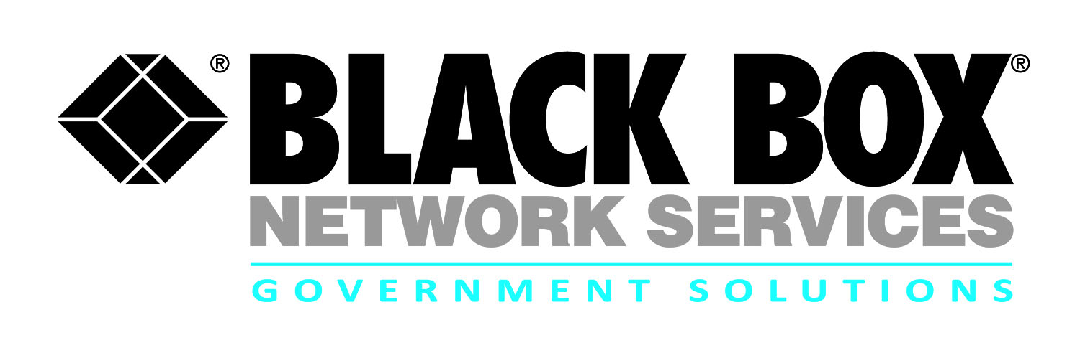
Contract review:
GSA Region 3 Telecommunications Services
Maintenance and Support Services (MSS2)

Black Box provides industry leading telecommunications services to federal agencies in the GSA Region 3 that covers the states of Virginia, Pennsylvania, Maryland Delaware and West Virginia providing comprehensive maintenance and support services (Note: exclusions include agencies in Montgomery, Prince George counties in MD; Arlington, Fairfax, Loudon, Prince William counties in VA; and the cities of Alexandria and Falls Church).

- Provides a rapid acquisition vehicle for government agencies for one-stop shopping for voice and data solutions and services

- Services include on-site Tier I/II/III up to OEM-level GTAC support, Remote monitoring, moves / adds / changes, data network administration and structured cabling for telecommunications systems

- Routine or emergency technical assistance support (TAS/ETAS) is available 24x7x365

- Installation and upgrade projects for voice and VoIP systems

- Customer service team is available Monday – Friday 8:00am – 5:00pm EST for all customer service related issues and to receive quick access to the right customer services resource to handle order placement and price quotes

The GSA Region 3 Telecommunications Services Contract encompasses a full range of products, services and solutions required for federal agencies in this region in support of the GSA, FAS Region 03-Philadelphia Regional Clients Acquisition Operations Division.

Contract # | GS03T12DSD7001
POP | 2-26-12 through 2-25-17
Who is Eligible | GSA Region 3 Federal Agencies
Agency | GSA FAS Region 03
Gov’t Contact | 215-446-5822
Email | sean.mchugh@gsa.gov

Solution Sets

- Voice and data equipment, services and solutions
- PBX and related equipment installation, upgrade, de-installation and support
- Project integration including design, procurement, installation and follow on support
- Structured cabling for telecommunication systems
- Network / Telecom Services
- Voice Over Internet Protocol (VoIP)
- Education and Training
- Remote monitoring 24x7
- Moves, adds and changes
- Procurement and quote services
- Equipment Maintenance
- Data network administration
- Legacy voice solutions modernization
- Program & Project Management
- Quality Assurance / Testing IV&V

For more information:

Robert Forshay
Partner Alliance Manager
Government Solutions
Black Box Network Services
781-292-3613 or robert.forshay@blackbox.com

Jim Gazzerro
Program Manager
Government Solutions
Black Box Network Services
540-817-3036 or james.gazzerro@blackbox.com

