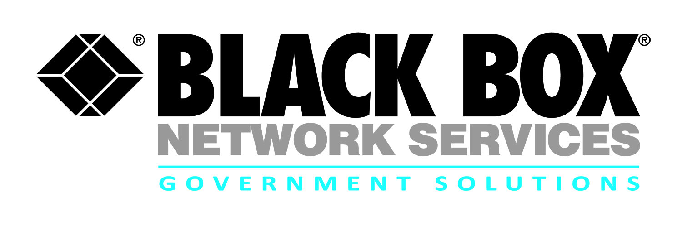
Contract review:
Army Infrastructure Modernization (IMOD)
Installation Information Infrastructure Modernization Program (I3MP)

Black Box provides industry leading communications infrastructure solutions to Army and DoD customers around the globe to support their infrastructure modernization requirements

- Under the IMOD contract Black Box Network Services supports the U.S. Army’s Installation Information Infrastructure Modernization Program (I3MP), a collection of voice, data, cable, long-distance gateway and enterprise management services, over Secured /Non-secure networks, for U.S. Army installations around the world

- Under this contract vehicle, Black Box Network Services executes a scope of services that seamlessly integrates voice, data, inside/outside plant cable plant and/or transmission products and services into a single integrated communications system. The scope also includes site preparation, modifications and upgrades, as well as initial logistics support to include training, spares, and various warranties

- Engineering, furnishing, installing, testing, integration, implementation, and enterprise services support for voice, data and infrastructure solutions, services and lifecycle support to the Army and DoD Agencies

- Minimize risk while modernizing the enterprise infrastructure by providing improved command and control (C2) and network efficiencies for the warfighter

The US Army’s IMOD-I3MP encompasses the full extent of services and supplies required to deliver global turnkey seamless solutions in support of the Project Manager, Installation Information Infrastructure Communications and Capabilities (I3C2) for the development and delivery of support systems managed by the Installation Information Infrastructure Modernization (I3MP) and Power Projection Enablers (P2E) Product Managers.

Contract # | W91QUZ-06-D-0027
POP | 4-28-06 through 4-27-16
Who is Eligible | Army
Agency | ACC-RIC
Gov’t Contact | 309-782-8991
Email | katherine.e.cromptonsilvis.civ@mail.mil

Solution Sets

- Systems Integration
- System Design & Architecture
- Administrative / Logistics / Support
- Applications Software
- Outside Plant (OSP) and Inside Plant (ISP)
- OSP/ISP Building Entrance Terminals (BET)
- Cross Connects, Premise Wiring, and Cable Plant
- Network / Telecom Services
- Computer Equipment
- Network Management Equipment
- Communications Equipment
- Data Management / Administration
- Education and Training
- Equipment Maintenance
- Video Tele-Conferencing (VTC) solutions
- Digital switching systems/ equipment
- Voice solutions including wireless, broadband, Voice Over Internet Protocol (VoIP)/Voice Over Secure Internet Protocol (VoSIP)
- Legacy voice solutions modernization
- LAN/WAN Equipment
- Planning & Analysis
- Program & Project Management
- Quality Assurance / Testing IV&V

For more information:

Robert Forshay
Partner Alliance Manager
Government Solutions
Black Box Network Services
781-292-3613 or robert.forshay@blackbox.com

Karen Sorenson
Director Contracts
Government Solutions
Black Box Network Services
703-885-7826 or karen.sorenson@federal.blackbox.com

