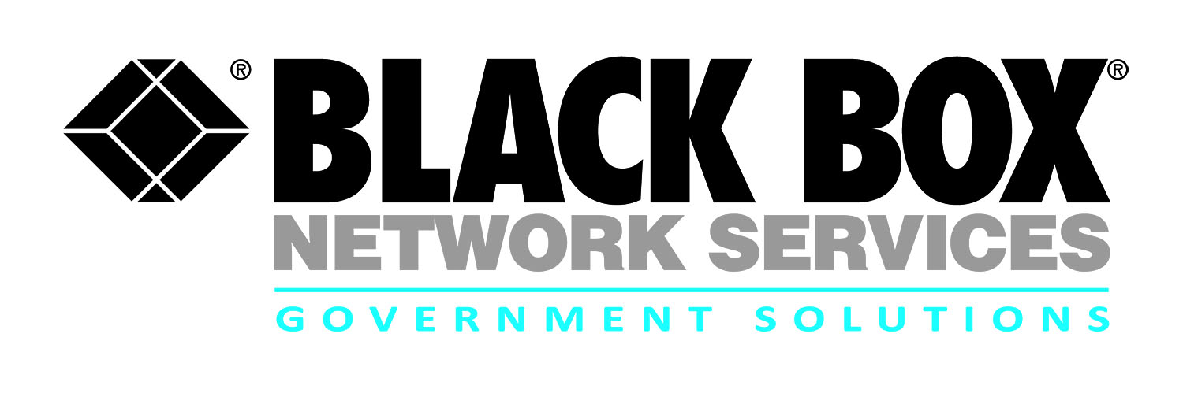
Contract review:

NETCENTS II NETOPS

Infrastructure Full & Open (NETCENTS 2)

Contract # | FA873215D0035
POP | 5-15-2015 through 5-15-2022
Who is Eligible | All Federal Agencies
Agency | Air Force Life Cycle Management Center, Business and Enterprise Systems (AFLCMC/HI)
Gov’t Contact | 334-416-5070
Email | netcents@us.af.mil
The U.S. Air Force's Network Centric Solutions 2 (NETCENTS 2) contract consists of a collection of acquisitions that have replaced the current NETCENTS contract vehicle with seven separate indefinite delivery, indefinite quantity (IDIQ) contracts. The total value of NETCENTS-II is $24+ billion over a seven-year period. NETCENTS-II is managed by the AFPEO Business Enterprise Services (BES) at Gunter Annex, Maxwell AFB. Under the NETCENTS-II NetOps and Infrastructure Solutions Full and Open ID/IQ contract structure, Black Box could provide an indefinite quantity of supplies or services through 2025 as this $7.9 billion ID/IQ contract provides a full range of information technology services and solutions.
The NETCENTS 2 contract provides all federal agencies access to a NO FEE vehicle encompassing a broad base of technical areas and serviced by industry leading companies like Black Box. Black Box offers several key advantages to customers through the NETCENTS 2 program:
- Scope of the Global NETCENTS 2 contract is an exact fit to Black Box’s core competencies and world-wide footprint.
- Global leadership in IT, Telecommunications, Security, Data Center, Network Technologies, and Infrastructure solutions.
- Global footprint and strategically located offices ensure that all task orders are managed by a regionally focused team of installation and project management personnel.
- Black Box’s strategic teaming partners enhance our solutions capabilities in communications, infrastructure, technical support and maintenance.
- Our expertise is serving the technology life cycle from consulting, planning and design through implementation, support and management.
- Black Box offers around-the-clock and around-the-globe support for all our solution implementations through five fully integrated Technical Assistance Centers located in the U.S. and more than 3,000 technical engineering and support Team Members worldwide.

Solution Sets:
- Managed Infrastructure
- Enterprise Level Security
- GIG Network Defense
- GIG Enterprise Management
- Outside Plant / Inside Plant
- Network Management / Network Defense
- Enterprise Messaging and Directory
- Enterprise Application Services
- Network Command and Control (C2)
- Data and Virtualization / Migration Services
- System Upgrade/Update Support
- Site Preparation
- Communications Operation and Maintenance
- Software Support
- Storage and Networking
- Disaster Recovery / COOP
- Information Lifecycle Management
- Metadata Infrastructure Services
- Legacy Infrastructure Support
- Voice Over IP

For more information:

Robert Forshay
Partner Alliance Manager
Government Solutions
Black Box Network Services
781-292-3613 or robert.forshay@blackbox.com

Caleb Mooney-McCoy
Account Executive
Government Solutions
Black Box Network Services
781-292-3608 or caleb.mooney-mccoy@blackbox.com

