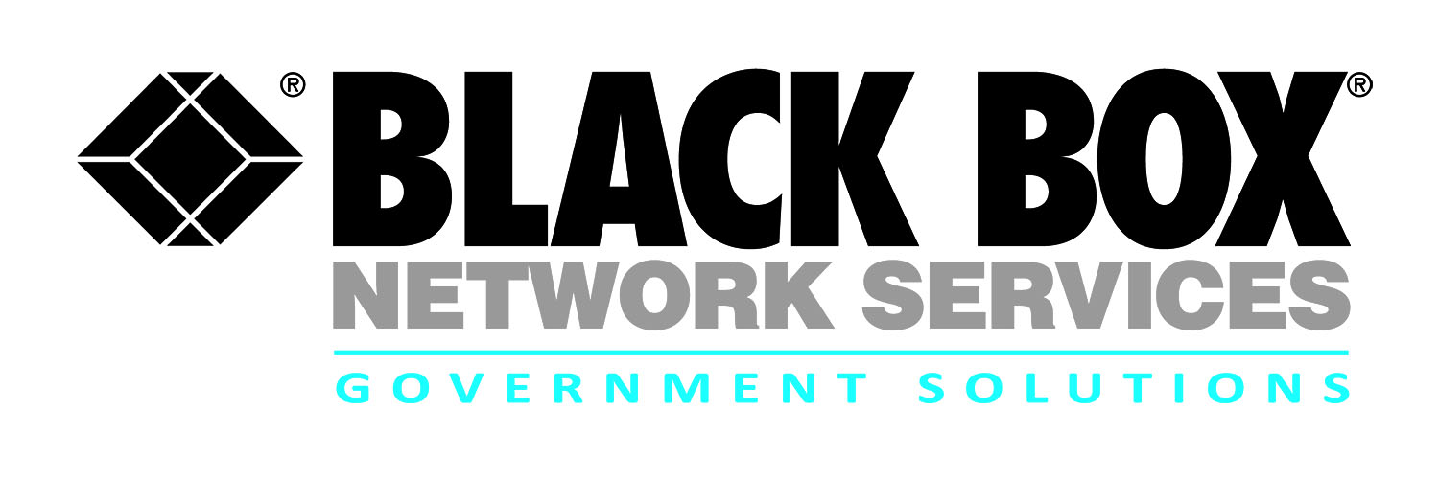
Contract review:
Navy SeaPort Enhanced (SeaPort-e)

Black Box provides support services for LAN / WAN and base communications infrastructure solutions to Navy customers around the globe. The SeaPort-e provides Navy customers access to:

- Perform maintenance and technical support for LAN / WAN that are outside of the Navy Marine Corps Intranet (NMCI)

- Provide engineering, integration and interface support for base related infrastructure that pertains to voice, data and information technology.

- Technical and program management and analysis, material acquisition, design, engineering, testing, logistical services, training, and authority to purchase any materials required to support these tasks

- Turn-key customer solutions from site preparation through equipment installation, cutover, migration support, training, initial logistics support including modifications and upgrades

- Support systems design, technical data reliability, maitainability, configuration and quality assurnace support for the LAN / WAN base infrastructure requirements

The Navy SeaPort-e multiple award contracts (MACs) were designed by the Naval Sea Systems Command (NAVSEA) to provide support services to Navy Systems Commands (NAVSEA, NAVAIR, SPAWAR, NAVFAC, NAVSUP, MSC, USMC, SSPO and ONR). Under SeaPort-e task orders are competed by the Warfare Center that has the requirement in the applicable zone of performance.
Note: Inside sales monitors and maintains the SeaPort-e/Bid link on a regular basis:
www.seaport.navy.mil
Contract # | N00178-08-D-5507
POP | 4-5-04 through 4-04-19
Who is Eligible | Navy
Agency | Naval Surface Warfare Center  Dahlgren Division, Seaport-e Office  Dahlgren, VA
Gov’t Contact | (540) 653-7087
Email | Gary.Byram@navy.mil

Solution Sets

- EFIT&C Voice & Data Networks
- Outside Plant (OSP) and Inside Plant (ISP)
- OSP/ISP Building Entrance Terminals (BET)
- Cross Connects, Premise Wiring, and Cable Plant
- Quality Assurance / Testing IV&V
- PBX and related equipment installation, upgrade, de-installation and support
- Equipment maintenance
- Remote monitoring 24x7
- Legacy voice solutions modernization
- Program & Project Management
- Digital switching systems/ equipment
- Voice Over Internet Protocol (VoIP)/Voice Over Secure Internet Protocol (VoSIP)
- Legacy voice solutions modernization
- Storage and networking
- Education & Training

For more information:

Robert Forshay
Partner Alliance Manager
Government Solutions
Black Box Network Services
781-292-3613 or robert.forshay@blackbox.com

Jeff Whitlock
Senior Contracts Specialist
Government Solutions
Black Box Network Services
781-292-3618 or jeff.whitlock@blackbox.com

