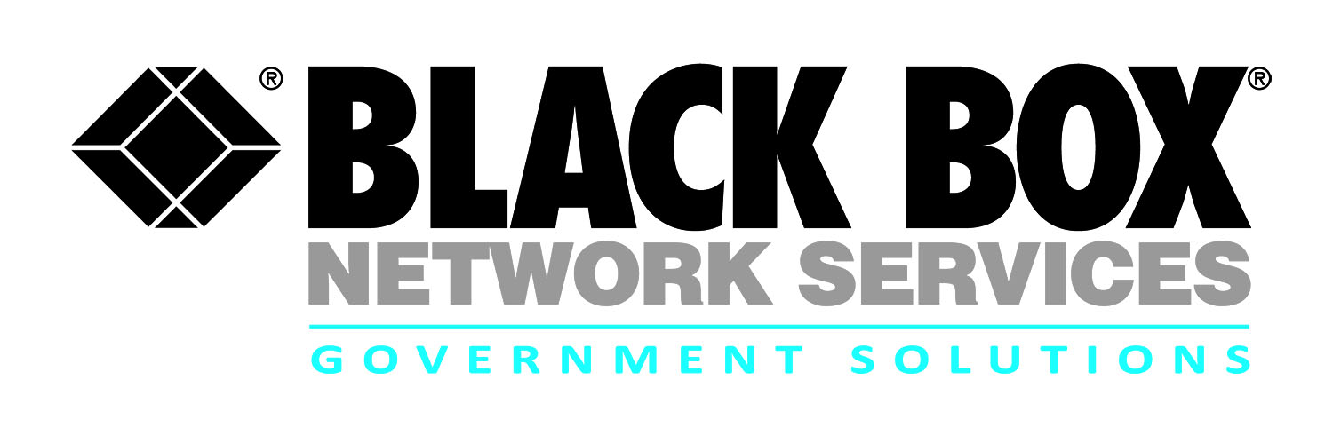
Contract review:
Navy SPAWAR Commercial off-The Shelf
Communications Products (COTS) Contract

Black Box provides rapid acquisition of communications equipment and related incidental support services to U.S. Government customers worldwide. The SPAWAR COTS contract provides Navy customers access to:

- Supply communications equipment, solutions, systems, accessories including software and all associated documentation requirements of the Navy, DoD, and federal agencies

- Support includes product validation authorization certification of manufacturer, products that are listed on the NIAP validated products list as required, provide unique identification and radio frequency identification as required, and product / item tracking per the contract

- Provide technical support services that include training, evaluation and repair, equipment configuration and setup, and upgrade kits

- Provide program management support to ensure that requirements are met on schedule and within cost

- Black Box has an extensive base of authorized Original Equipment Suppliers (OEMs) for communications products as the largest independent supplier of communication solutions.
The US Navy‘s SPAWAR COTS contract encompasses the full extent of COTS equipment and services required to deliver global network, communications, and service capabilities in support of the Space and Naval Warfare Systems Centers SPAWARSYSCEN Ordering Officer in support of DoD and federal agencies.
Note: Inside Sales (John Pantano) monitors the SPAWAR COTS portal on a regular baisis
Contract # | N65236-12-D-4130
POP | 3-22-12 through 3-21-17
Who is Eligible | Navy
Agency | SPAWAR
Gov’t Contact | 843-218-3975
Email | diane.crosby@navy.mil

Solution Sets

- Enterprise Services and Capabilities
- Rapid acquisition process
- Video Tele-Conferencing (VTC) solutions
- Digital switching systems/ equipment
- Voice solutions including wireless, broadband, Voice Over Internet Protocol (VoIP)/Voice Over Secure Internet Protocol (VoSIP)
- Legacy voice solutions modernization
- Upgrade kits
- Storage and networking
- Training both factory and onsite
- Equipment documentation
- Equipment configuration and set up
- Evaluation and repair
- Information Assurance
- Patch panels, splitters and distribution units
- Power distribution units
- Chassis, mounting enclosures and shelters
- Program management
- Maintenance services

For more information:

Robert Forshay
Partner Alliance Manager
Government Solutions
Black Box Network Services
781-292-3613 or robert.forshay@blackbox.com

Jim Billings
Director of Sales
Government Solutions
Black Box Network Services
434-946-1603 or james.billings@blackbox.com

