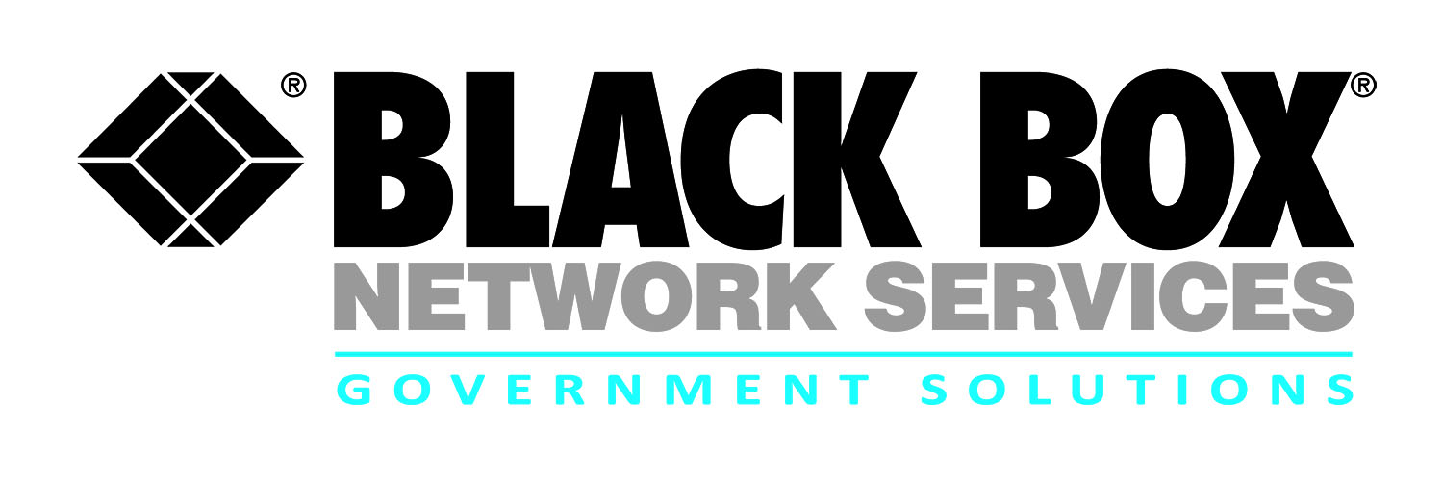
Contract review:
Worldwide Communications and Infrastructure
Support (WCIS) Basic Ordering Agreement (BOA)

Black Box provides industry leading communications infrastructure solutions to Army customers around the globe. The WCIS BOA provides Army customers access to:

- Engineering, furnishing, installing, testing, integration, implementation, and enterprise services support for the complete spectrum of IT equipment and service requirements of the Army and DOD

- Solution development, process development, integration and implementation of COTS IT products and services

- Technical and program management and analysis, material acquisition, design, engineering, testing, logistical services, training, and authority to purchase any materials required to support these tasks

- Turn-key customer solutions from site preparation through equipment installation, cutover, migration support, training, initial logistics support including modifications and upgrades

- In addition to our internal resources, Black Box has assembled a team of industry leaders chosen for their expertise and core competencies in specific task areas of this program. With redundancy support through our teaming partners, we can support multiple simultaneous efforts on a worldwide scale

The US Army’s WCIS BOA encompasses the full extent of services and supplies required to deliver global WCIS capabilities in support of the Project Manager Installation Information Infrastructure – Communications and Capabilities (I3C2) mission including the subordinate Product Manager Installation Information Infrastructure Modernization Program (I3MP), Manager Power Projection Enablers (P2E), and Product Director Korea Transformation (KT) and any future I3C2 organization.
Contract # | W52P1J14G0011
POP | 1-16-14 through 1-15-17
Who is Eligible | Army
Agency | PEO-EIS, PM I3C2
Gov’t Contact | (703) 806-8626
Email | patricia.a.silvola.civ@mail.mil

Solution Sets
- Technical Control Facilities (TCF)
- Wireless Technologies
- Outside Plant (OSP) and Inside Plant (ISP)
- OSP/ISP Building Entrance Terminals (BET)
- Cross Connects, Premise Wiring, and Cable Plant
- Data Stacks and Top Level Architecture (TLA) Stacks
- Heating, ventilation, and air conditioning (HVAC)
- Power generation
- Data and Virtualization Services
- Enterprise Services and Capabilities
- Distributed Systems Integration
- Video Tele-Conferencing (VTC) solutions
- Digital switching systems/ equipment
- Voice solutions including wireless, broadband, Voice Over Internet Protocol (VoIP)/Voice Over Secure Internet Protocol (VoSIP)
- Legacy voice solutions modernization
- Storage and networking
- Data and application virtualization and migration
- Disaster Recovery Continuity of Operations (DR/COOP)
- Terrestrial, Line of Sight (LOS) and wireless communications infrastructure

For more information:

Robert Forshay
Partner Alliance Manager
Government Solutions
Black Box Network Services
781-292-3613 or rob.forshay@blackbox.com

Jeff Whitlock
Senior Contracts Specialist
Government Solutions
Black Box Network Services
781-292-3618 or jeff.whitlock@blackbox.com

