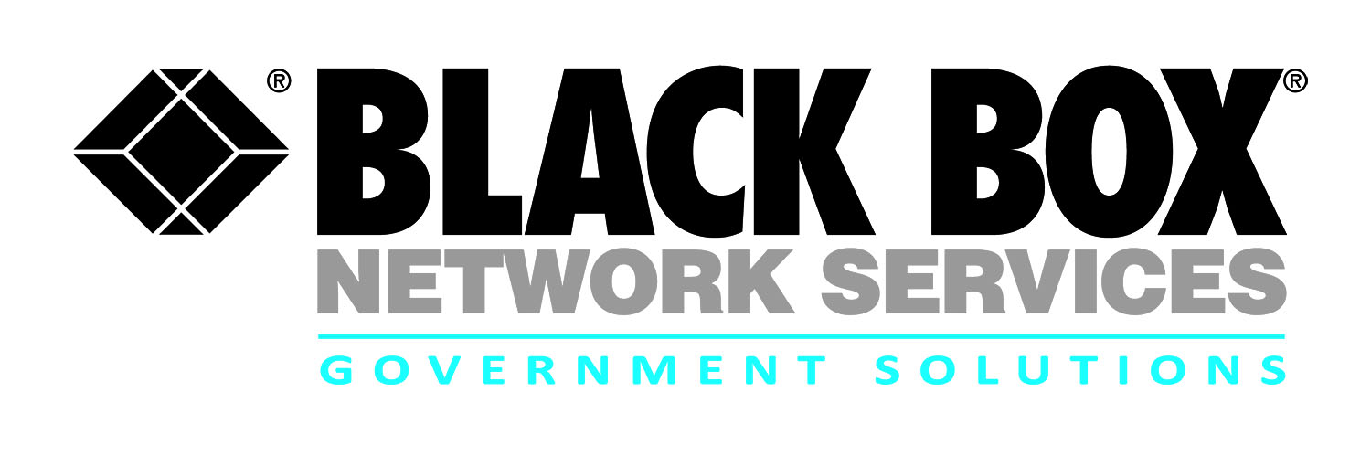
Contract review:
GSA Schedules

GSA establishes long-term Government-wide contracts with commercial firms to provide access to millions of commercial products and services at volume discount pricing. These can be ordered directly from GSA Schedule contractors or through the GSAAdvantage!® online shopping and ordering system.

Black Box GSA Schedule 70:
http://www.blackbox.com/solutions/government-solutions/contract-vehicles/gsa-schedules-and-gwacs.aspx

Black Box Network Services holds several GSA Schedule 70 contracts for general purpose commercial IT equipment, software and services:
- GSA Schedule 70 # GS-35F-0158J
(Black Box)
http://www.blackbox.com/Store/special-programs/government/index.aspx

- GSA Schedule 70 # GS-35F-0087L
(Quanta, contract end Nov ‘15)

- GSA Schedule 70 # GS-35F-0905R
(MTS) includes special item numbers (SIN):
  - 132-08 – Equipment
  - 132-12 – Equipment Maintenance
  - 132-33 – Software (Perpetual License)
  - 132-34 – Software Maintenance

Black Box Network Services also holds the following GSA schedule providing total solutions for law enforcement, security, facilities management, fire, rescue, clothing, marine craft, and emergency/disaster response:
- GSA Schedule 84 # GS-07F-0736X (Quanta)

Other GSA Schedules Black Box utilizes (sample OEM’s below:

Black Box is an authorized, non-exclusive, independent dealer providing professional IT services and telecom products on the following schedules (sample):

- Westcon GSA Schedule # GS-35F-0563U
(Cisco)
- IMMIX GSA Schedule GS-35F-0511T
(Brocade via Tech Data)
- GS-35F-0156V IT services and telecom products
(Avaya -Red)

For more information:

Robert Forshay
Partner Alliance Manager
Black Box Network Services - Government Solutions
781-292-3613 or robert.forshay@blackbox.com

Jeff Whitlock
Senior Contracts Administrator
Black Box Network Services - Government Solutions
781-292-3618 or jeff.whitlock@blackbox.com

GSA Website:
http://www.gsa.gov/portal/content/197989

